**Module 4: Systems of Equations and Matrices**

**I. Systems of Equations in Two Variables**

After completing this section, you should be able to:

* verify whether an ordered pair is a solution of a system of equations in two variables
* solve systems of two linear equations in two variables using the substitution method and the elimination method
* solve applied problems related to systems of equations in two variables

**A. Solution of a System of Equations in Two Variables**

The equation 2*x* + 3*y* = 12 is an example of a linear equation in two variables, *x* and *y*. The graph of the equation is a line, shown below. Two points on this line are the intercepts (6, 0) and (0, 4). (See module 1, topics I-A and II-E for a review of lines and intercepts.)

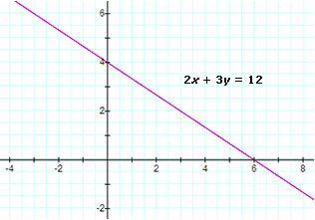

More generally, a **linear equation in two variables** is equivalent to an equation of the form *ax* + *by* = *c*, where *a*, *b*, and *c* are real numbers, and the coefficients *a* and *b* are not both 0.

A **system of two linear equations in two variables** consists of a pair of linear equations

*a*1*x* + *b*1*y* = *c*1  
*a*2*x* + *b*2*y* = *c*2

A system of this form is called a **2 × 2 system**, because there are two equations and two variables.

A solution of the system of linear equations is a pair (*x*, *y*) that satisfies both of the linear equations. Since the graph of each linear equation is a line, any solution (*x*, *y*) must be a point on both of the lines. In other words, if a solution (*x*, *y*) exists, it must be a point of intersection of the two lines.

**Example I.A.1:** Verify that the ordered pair (4, –1) is a solution of the following system of equations. Graph the lines and the solution.

*x* + *y* = 3  
*x* – *y* = 5

**Solution:**

Substitute *x* = 4 and *y* = –1, and check to see if both equations are satisfied:

|  |  |  |
| --- | --- | --- |
| *x* +     *y* ? 3 |  | *x* – *y*  ? 5 |
| 4 + (–1) ? 3 |  | 4 – (–1) ? 5 |
| 3 = 3 |  | 5 = 5 |
| The first equation is satisfied. |  | The second equation is satisfied. |

Since the ordered pair (4, –1) makes both of the equations true, it is a solution of the system of equations.

The graph of the first equation is a line having intercepts (3, 0) and (0, 3).

The graph of the second equation is a line having intercepts (5, 0) and (0, –5).

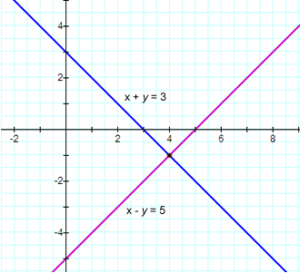

The intersection of the two lines is the point (4, –1), the solution of the system of equations.

Example I.A.1 illustrates a situation where a pair of linear equations corresponds to two intersecting lines with one point in common. However, it is possible that a pair of linear equations corresponds to two parallel lines, so the lines have no point in common. In this case, the system of equations has no solution. It is also possible that a pair of two linear equations describes two identical lines, which have infinitely many points in common. In this case, the system of equations has infinitely many solutions. These two cases are demonstrated in examples I.A.2 and I.A.3, respectively.

**Example I.A.2:** Show graphically that the following system of equations has no solution.

*x* + *y* = 3  
2*x* + 2*y* = 8

**Solution:**

The graph of the first equation is a line having intercepts (3, 0) and (0, 3).

The graph of the second equation is a line having intercepts (4, 0) and (0, 4).

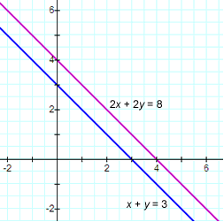

The line through the points (3, 0) and (0, 3) has slope (0 – 3)/(3 – 0) = –1.

The line through the points (4, 0) and (0, 4) has slope (0 – 4)/(4 – 0) = –1.

The lines have the same slope. They are parallel and there is no point in common; there is no ordered pair (*x*, *y*) that satisfies both equations. The system of equations has no solution.

**Example I.A.3:** Show graphically that the following system of equations has infinitely many solutions.

*x* + *y* = 3  
2*x* + 2*y* = 6

**Solution:**

The graph of the first equation is a line having intercepts (3, 0) and (0, 3).

The graph of the second equation is also a line having intercepts (3, 0) and (0, 3).

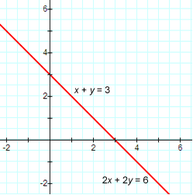

The lines corresponding to the two equations have the same intercepts, so they must be identical. Every point on the line with intercepts (3, 0) and (0, 3) is a solution of the system of equations. There are infinitely many solutions.

Note that the equations in examples I.A.2 and I.A.3 are very similar in appearance (all but one constant are the same). However, the graphs revealed very different outcomes in terms of the number of solutions.

A system of linear equations is called **consistent** if it has at least one solution. A system is **inconsistent** if it has no solution. The systems examined in examples I.A.1 and I.A.3 are consistent. The system examined in example I.A.2 is inconsistent.

In summary, given a system of two linear equations in two variables, the system must belong to one of the three types shown below.

|  |  |  |
| --- | --- | --- |
| **Consistent 2 × 2 Systems** | | **Inconsistent 2 × 2 System** |
| https://umuc.equella.ecollege.com/file/51ed41e5-be80-4110-8171-a40ed58c98af/1/MATH108-0609.zip/Modules/M4-Module_4/images/Mod4-5a.gif | https://umuc.equella.ecollege.com/file/51ed41e5-be80-4110-8171-a40ed58c98af/1/MATH108-0609.zip/Modules/M4-Module_4/images/Mod4-5b.gif | https://umuc.equella.ecollege.com/file/51ed41e5-be80-4110-8171-a40ed58c98af/1/MATH108-0609.zip/Modules/M4-Module_4/images/Mod4-5c.gif |
| Lines having one point of intersection | Identical lines | Parallel lines; no point of intersection |
| One solution | Infinitely many solutions | No solution |

**B. The Substitution Method**

There are several common analytical approaches used to solve a system of two linear equations in two variables. Below we present one such approach, the substitution method.

**The Substitution Method**

Start by choosing one of the two linear equations. Using the equation, find an algebraic expression for one of the variables (say *y*, for instance) in terms of the other variable (*x*). Substitute the expression for *y* into the other linear equation. Now there is an equation involving just one variable, *x*. Solve for *x*. Then substitute the value of *x* into the expression for *y* and compute the *y*-value.

**Example I.B.1:** Solve the following 2 × 2 system using the substitution method.

*x* + *y* = 3  
*x* - *y* = 5

**Solution:**

Select an equation and a variable. Suppose the first equation is selected and you choose to solve for *y* in terms of *x*.

|  |  |
| --- | --- |
| *x* + *y* = 3 | Select the first equation. |
| *y* = 3 - *x* | Solve for *y*. |
| Substitute *y* = 3 – *x* into the second equation: | | |
| *x* – *y*     = 5 | Recall the second equation. |  |
| *x* – (3 – *x*) = 5 | Substitute for *y*. |  |
| 2*x* – 3 = 5 | The equation only involves one variable, *x*. |  |
| 2*x* = 8 | Simplify. |  |
| *x* = 4 | Solve for *x*. |  |
| Substitute *x* = 4 into the expression for *y*: | | |
| *y* = 3 –   *x* |  |  |
| *y* = 3 – (4) | Substitute for *x*. |  |
| *y* = –1 | Simplify. |  |

The system of equations is consistent.

The solution of the system is the ordered pair (4, –1). You can verify your solution by checking to see that (4, –1) satisfies both of the original equations. This process was illustrated in example I.A.1.

If you selected the first equation and began by solving for *x* in terms of *y*, the substitution method would still lead you to the same solution (4, –1). Also, if you began by selecting the second equation rather than the first equation, the substitution method would still lead you to the same solution (4, –1).

**C. The Elimination Method**

There are several common analytical approaches used to solve a system of two linear equations in two variables. We examined the substitution method in section I-B. Below we present another approach, the elimination method.

**The Elimination Method**

Look for a way to add or subtract a multiple of one equation to or from a multiple of the other equation in order to eliminate one of the variables. (For example, if the left side of one of the equations has a term of 2*y* and the left side of the other equation has a term of –2*y*, then adding the two equations will result in 0*y* and the variable *y* will be eliminated.)

Once a variable has been eliminated, you are left with an equation involving just one variable. Solve the equation for that variable. Substitute the value of that variable back into one of the original equations, and solve for the remaining variable.

**Example I.C.1:** Solve the following 2 × 2 system using the elimination method.

*x* + *y* = 3  
*x* – *y* = 5

**Solution:**

Since the first equation has a term of *y* and the second equation has a term of –*y*, eliminate the variable *y* by adding the two equations together:

|  |  |
| --- | --- |
| *x* + *y* = 3 |  |
| *x* – *y* = 5 |  |
| 2*x*       = 8 | Add the equations. |
| *x* = 4 | Solve for *x*. |
| Substitute *x* = 4 back into either of the original equations. | | |
| *x*  + *y* = 3 | Select the first equation. |  |
| (4) + *y* = 3 | Substitute for *x*. |  |
| *y* = –1 | Solve for *y*. |  |

The system of equations is consistent.

The solution of the system is the ordered pair (4, –1).

Alternative choices could have been made in carrying out the elimination method for this system. For example, if one of the equations is subtracted from the other equation, then the variable *x* is eliminated. The resulting equation only involves *y*. With this approach, you would solve for the *y*-value, substitute it back into one of the original equations, and then find the *x*-value.

Next, consider a slightly more complicated example.

**Example I.C.2:** Solve the following 2 × 2 system using the elimination method.

2*x* + 3*y* = 4  
3*x* + 4*y* = 9

**Solution:**

2*x* + 3*y* = 4  (1)  
3*x* + 4*y* = 9  (2)

For this system, merely adding or subtracting the equations will not eliminate one of the variables. However, if you first multiply both sides of the two equations by appropriate numbers, and then add the equations, you can eliminate a variable. There are many ways to accomplish this task. For example, notice that the coefficients of the *x* terms are 2 and 3. The least common multiple is 6. What can you do to manipulate the equations so that the coefficients of the *x* terms are 6 and –6? Here is one possibility:

|  |  |
| --- | --- |
| 6*x* + 9*y =* 12 | Multiply equation (1) by 3. |
| –6*x* – 8*y* = –18 | Multiply equation (2) by –2. |
| *y* = –6 | Add the equations. |
| Now substitute *y* = –6 back into equation (1) or equation (2): | | |
| 2*x* +    3*y* = 4 | Select equation (1). |  |
| 2*x* + 3(-6) = 4 | Substitute for *y*. |  |
| 2*x* – 18 = 4 | Calculate. |  |
| 2*x* = 22 | Simplify. |  |
| *x* = 11 | Solve for *x*. |  |

The system of equations is consistent.

The solution of the system is the ordered pair (11, –6). The solution can be verified by checking to see that it satisfies both equations (1) and (2). The graphs of the lines and the solution are displayed below.

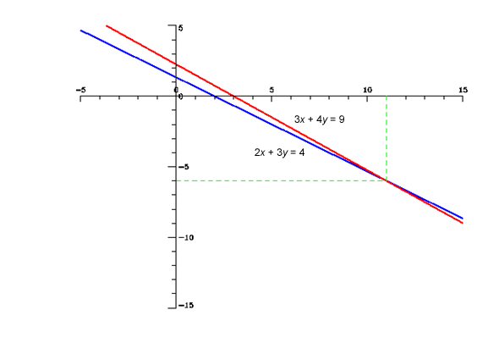

Consider the systems in examples I.A.2 and I.A.3, which were examined graphically in topic I-A. Below, we will examine them again using the elimination method.

**Example I.C.3:** Solve the following 2 × 2 system using the elimination method.

*x* + *y* = 3  
2*x* + 2*y* = 8

**Solution:**

*x* + *y* = 3     (1)  
2*x* + 2*y* = 8  (2)

If equation (1) is multiplied by –2, then the resulting equation can be added to equation (2) to eliminate a variable:

|  |  |
| --- | --- |
| –2*x* – 2*y* = –6 | Multiply equation (1) by –2. |
| 2*x* + 2*y* =   8 | Leave equation (2) as is. |
| 0 = 2 | Add the equations. |

0 is not equal to 2. There are no values for *x* and *y* which make the equation 0 = 2 true. Therefore, the system is inconsistent. There is no solution.

The graphs of the equations are parallel lines, as shown in example I.A.2.

From this, we can develop the following general rule.

If the elimination method results in an equation of the form 0 = *c*, where *c* is nonzero, then the 2 × 2 system is inconsistent and has no solution.

**Example I.C.4:** Solve the following 2 × 2 system using the elimination method.

*x* + *y* = 3  
2*x* + 2*y* = 6

**Solution:**

*x* + *y* = 3     (1)  
2*x* + 2*y* = 6  (2)

If equation (1) is multiplied by –2, then the resulting equation can be added to equation (2) to eliminate a variable:

|  |  |
| --- | --- |
| –2*x* – 2*y* = –6 | Multiply equation (1) by –2. |
| 2*x* + 2*y* =   6 | Leave equation (2) as is. |
| 0 = 0 | Add the equations. |

Regardless of the values of *x* and *y*, 0 is equal to 0.

Adding the equations and getting the result 0 = 0 implies that each of the equations is the negative of the other. More generally, one equation is a multiple of the other—notice that equation (2) is two times the original equation (1). These equations represent the same line. Because of this, any solution of one equation is a solution of the other equation. The system is consistent, and there are infinitely many solutions.

Take one of the equations and solve for *y*:

|  |  |
| --- | --- |
| *x* + *y* = 3 | Choose equation (1). |
| *y* = 3 – *x* | Solve for *y*. |

The solutions of the system are the ordered pairs (*x*, *y*) = (*x*, 3 – *x*), where *x* is any real number.

For instance,

* for *x* = 0, the ordered pair (*x*, 3 – *x*) = (0, 3 – 0) = (0, 3) is a solution, and
* for *x* = 5, then (*x*, 3 – *x*) = (5, 3 – 5) = (5, –2) is a solution.

Similarly, the solutions could be written in terms of *x*:

|  |  |
| --- | --- |
| *x* + *y* = 3 | Choose equation (1). |
| *x* = 3 – *y* | Solve for *x*. |

The solutions of the system are the ordered pairs (*x*, *y*) = (3 – *y*, *y*), where *y* is any real number.

As before, we can develop the following general rule.

If the elimination method results in an equation of the form 0 = 0, then the 2 × 2 system is consistent and has infinitely many solutions.

Many applications lead to a system of equations in two variables. Here is one example.

**Example I.C.5:** A charitable organization sponsored a dinner to raise funds. Tickets cost $12 for adults and $8 for children ages ten and younger. A total of $9,000 was collected through the sale of 800 tickets. How many tickets sold were adult tickets and how many were children's tickets?

**Solution:**

First define the variables of interest:

* Let *x* = the number of adult tickets.
* Let *y* = the number of children's tickets.

The goal is to determine the values of *x* and *y*.

Organize the information provided in the problem and formulate two equations in two variables:

|  |  |  |  |  |
| --- | --- | --- | --- | --- |
| **Type of Ticket** | Adult | Child | Total | Equation |
| **Number of Tickets** | *x* | *y* | 800 | *x* + *y*= 800 |
| **Revenue Collected** | 12*x* | 8*y* | $9,000 | 12*x* + 8*y*= 9,000 |

In order to determine the values of *x* and *y*, solve the system:

|  |  |
| --- | --- |
| *x* + *y*= 800 | (1) |
| 12*x* + 8*y*= 9,000 | (2) |

Apply the substitution method or the elimination method. Suppose the elimination method is chosen. To eliminate *x*, multiply the first equation by –12 and then add it to the second equation:

|  |  |
| --- | --- |
| –12*x* – 12*y* = –9,600 | Multiply equation (1) by –12. |
| 12*x* +   8*y* =   9,600 | Leave equation (2) as is. |
| –4*y* =    –600 | Add the equations. |
| *y* = 150 | Solve for *y*. |
| Now substitute *y* = 150 back into equation (1) or equation (2) and solve for *x*: | | |
| *x* +     *y* = 800 | Select equation (1). |  |
| *x* + (150) = 800 | Substitute for *y*. |  |
| *x* = 650 | Solve for *x*. |  |

The solution (*x*, *y*) = (650, 150).

The number of adult tickets = *x* = 650 and the number of children's tickets = *y* = 150.

It is a good idea to check the results.

There are 650 + 150 = 800 tickets all together, which is the total stated in the problem.

The revenue collected is $12(650) + $8(150) = $7,800 + $1,200 = $9,000, equal to the total revenue stated in the problem.

In conclusion, there were 650 adult tickets sold and 150 children's tickets sold.

[*Return to top of page*](https://umuc.equella.ecollege.com/file/51ed41e5-be80-4110-8171-a40ed58c98af/1/Systems%20of%20Equations%20in%20Two%20Variables.html#pagetop)

[**Report broken links or any other problems on this page.**](http://help.umuc.edu/)  
  
[**Copyright © by University of Maryland University College.**](https://umuc.equella.ecollege.com/file/common/copyright.html)